Revised models

Model 1
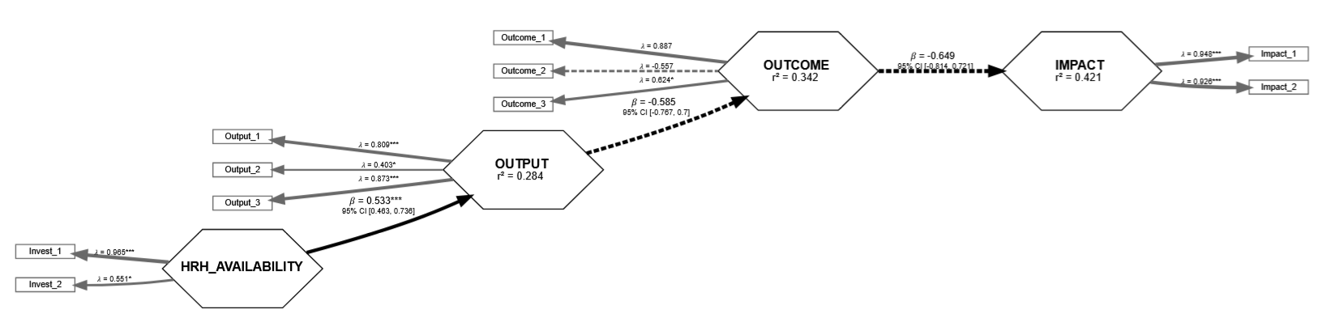
Investment to Output
For every additional $1 per capita invested in health workforce availability......you see a 53.3% increase in service availability, based on the strong path coefficient (0.533, T = 7.56, CI = [0.463, 0.736]).

Output to Outcome (DALYs)
This improved service availability, in turn, leads to a reduction in disease burden...(measured in DALYs)
The path coefficient from OUTPUT to DALYs (OUTCOME) is -0.585, meaning that better service availability reduces DALYs, i.e., more healthy life years are preserved.

DALYs to Economic Impact
Smaller DALYs — a good thing — translates into higher national productivity and GNP per capita...
The OUTCOME to IMPACT path is -0.649, implying that a reduction of one DALY is associated with a significant increase in GNP per capita.

Model 2

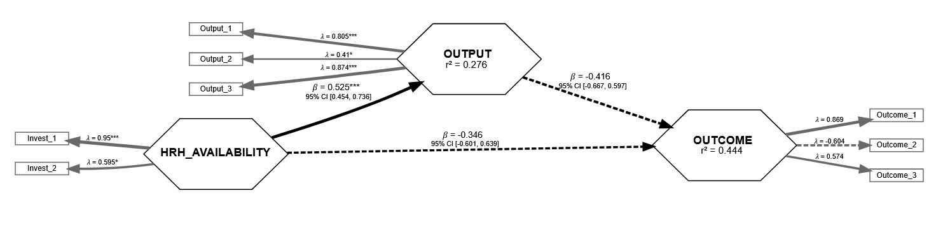

The new route Investment to DALYs
Directly, every $1 per capita invested reduces DALYs by 0.346 units per capita, although this is statistically weak (T = -0.948) — possibly due to indirect effects or mediators being omitted.

Model 3

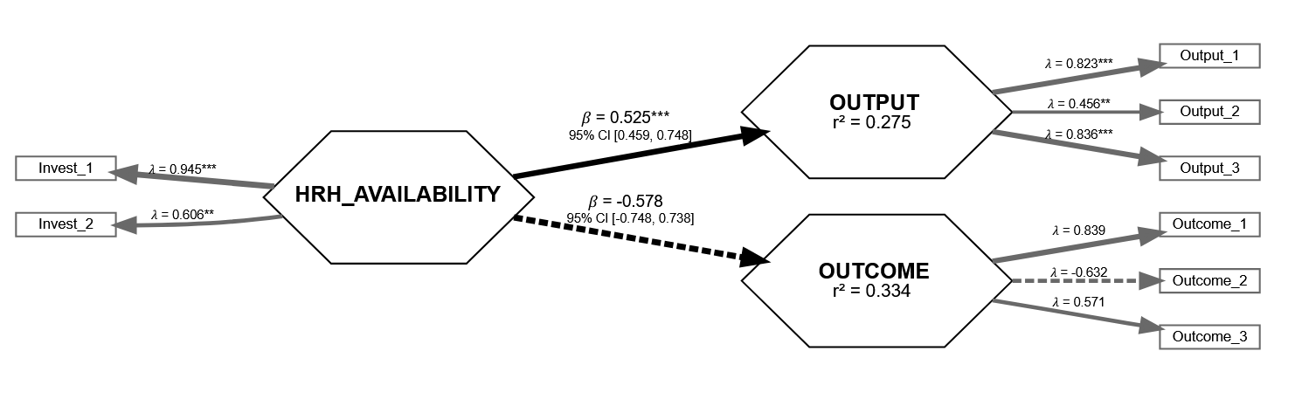

Holding everything constant (that is without the influence of both HRH and outputs on Outcomes) same $1 investment is associated with a 0.578-unit reduction in DALYs (i.e. healthier lives), though this effect has statistical uncertainty (T = -0.98).

The full Model

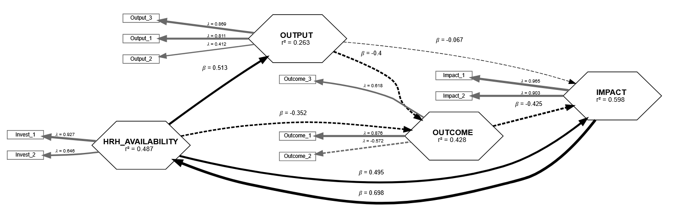

Model: direct relationships

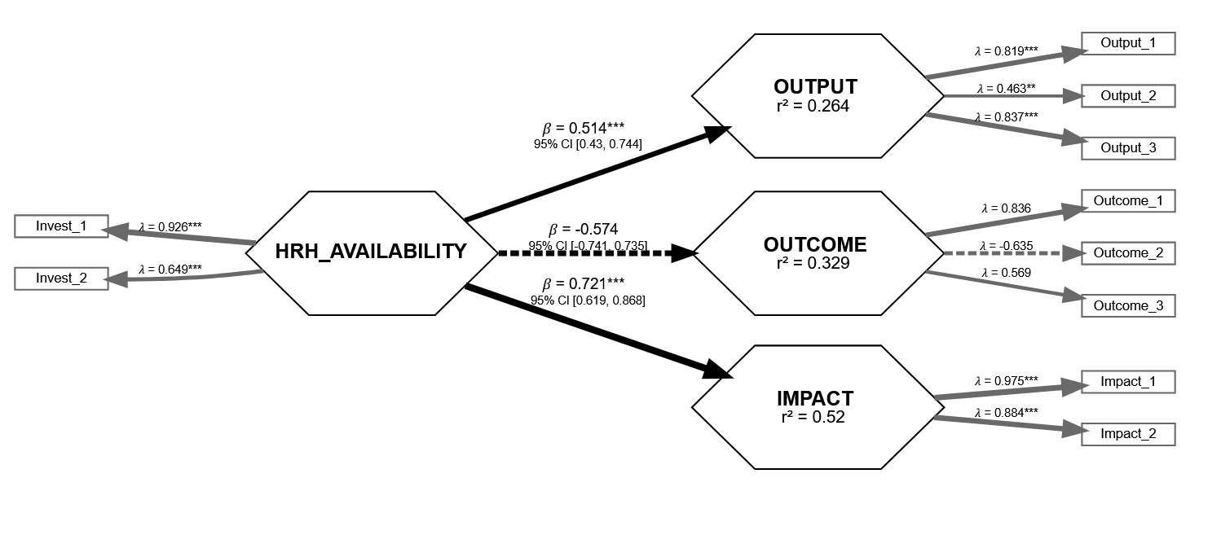
The new line of association
Investment → GNP per Capita / Productivity (Impact)
Now the headline metric: Every $1 investment per capita results in a 0.721-unit increase in national productivity. This will be inbuild into the current levels of impact
- This path is statistically powerful (T = 10.84, CI [0.619, 0.868])
- Impact construct is exceptionally stable, with Impact_1 loading = 0.975 and internal consistency solid (α = not shown, but loadings & T values very strong).
This gives the ROI angle: Dollar-for-dollar, HRH investments not only enhance service capacity but also correlate with gains in economic productivity.

Overall: "$1 invested → +0.51 in service availability → ~0.57 reduction in DALYs → +0.72 gain in GNP per capita."

